The Fifth US-Japan Symposium
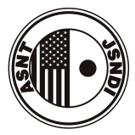

Emerging NDE Capabilities for a Safer World

Abstract Form

Ref.20130927
1 | Paper Title:
2 | Presenting Author(s) full name :
2 | First Name |  |  |  | Middle Name |  |  |  | Family Name
3 | Membership No.
4 | Presenting Author’s Company Name(s):
6 | Co-Author(s) :
6 | Full name |  |  |  |  | Company Name(s)
7 | Contact Author’s Information:
7 | Name
7 | Address
7 | Country
7 | Phone |  |  |  |  |  | Fax
7 | E-mail
8 | Body of Abstract : (200 words, 12point font)
9 | Keywords: (limit six words)
10 | Symposium Topics:
10 | No. | Topics

